Use Case Specification

DMT/RM01/TMP

|  |  |
| --- | --- |
| Project Code | PRJ_Airline Reservation System _001 |
| Project Name | Airline Reservation System |

|  |  |  |
| --- | --- | --- |
| Prepared/Modified by | Role | Date of Preparation |
| Dhanalakshmi | Software Analyst | 24th February, 2018 |
| Reviewed by | Role | Date of Review |
| Dayanand Patil | Mentor |  |
| Approved by | Role | Date of Approval |
| Dayanand Patil | Mentor |  |
| Circulation List |  | Version Number of the template:1.1 |
| Version Number | 1.1 |  |

<<Customer>> REVIEW HISTORY

<<Customer comments on the Use case along with the signed off is tracked here>>

|  |  |  |  |  |  |  |
| --- | --- | --- | --- | --- | --- | --- |
| Version | 1.0 |  |  |  |  |  |
| Date | <<Date of Review>> |  |  |  |  |  |
| Reviewed by | << Reviewer Name>> |  |  |  |  |  |
| Reviewed UI Specification doc | << Whether UI Specification doc is reviewed >> |  |  |  |  |  |
| All Open Queries/issues closed | << Whether all the open queries and issues resolved>> |  |  |  |  |  |
| Agreement on Assumptions | <<Whether all the assumptions have been agreed upon by the customer>> |  |  |  |  |  |
| Sign Off | <<Signature>> |  |  |  |  |  |

Disclaimer:

The scope of the project ‘**Airline Reservation System’** is restricted to the contents of this signed off use case.

TABLE OF CONTENTS

1. Use Case Name: View flight details by period to the Airline Reservation System 5

2. Actor(s) 5

3. Preconditions 5

4. Flow of Events 5

4.1 Basic Flow 5

4.2 Alternative Flows 5

4.2.1 Alternate Flow 1: successful login to OBS on second attempt 5

4.2.2 Alternate Flow 2 : Login to the OBS using Apply for Courses option 6

4.2.3 Alternate Flow 3 6

Exception Flow 1: Exceeded Login Attempts 6

Exception Flow 2: Web Server Down 6

Exception Flow 3: Database Connectivity Error 6

Exception Flow 4: Network Connectivity Error 7

5. Post Conditions 7

6. Special Requirements 8

Performance 8

Availability 8

Admin Interface 8

Security 8

7. Extension Points 8

Extension in Alternate Flow 1: 8

Extension in Alternate Flow x: 8

8. Business Rules 8

9. Diagrams 9

Use Case Diagram for 9

10. Scenarios 10

Success Scenarios 10

Failure Scenarios 10

11. Issues 10

12. UI Specifications 10

13. Inter System Dependencies 10

14. Integration with an already existing System of the <<Customer>> 10

15. Assumptions 11

**Use Case ID:**  EXECUTIVE.VIEWFLIGHTSBYPERIOD_001

**Brief Description:** This Use Case describes the process by which the executive can view flights occupancy details by period in the Airline Reservation System.

1. Actor(s)
2. Executive
3. Preconditions
4. Executive is an employee of Airline Reservation System.
5. Executive has an access to the Airline Reservation System
6. Executive has valid User name and the password
7. Executive has already logged in to the Airline Reservation System
8. Flow of Events

4.1 Basic Flow

Name: Successfully view flights occupancy details by period in Airline Reservation System

1. Executive clicks on Flights based on Period radio button available on Details page .
2. Executive will be navigated to flights between page.
3. Executive enters the From Date
4. Executive enters the To Date
5. Executive clicks on Search button
6. The system navigates Executive to the Flight Schedule Based On Period page
7. Executive successfully view the Flight Occupancy Status
   1. Alternative Flows

4.2.1 Alternate Flow 1: Wrong Attempts By leaving From date field empty

1. Executive clicks on Flights based on Period radio button available on Details page .
2. Executive will be navigated to flights between page.
3. Executive enters the To Date
4. Executive clicks on Search button
5. The system ask the executive to enter the From Date.
6. The system takes executive to the **Step 3** of **Basic Flow**

4.2.2 Alternate Flow 1: Wrong Attempts By leaving To date field empty

1. Executive clicks on Flights based on Period radio button available on Details page .
2. Executive will be navigated to flights between page.
3. Executive enters the From Date
4. Executive clicks on Search button
5. The system ask the executive to enter the From Date.
6. The system takes executive to the **Step 3** of **Basic Flow**
   * 1. Alternate Flow 1: Wrong Attempts By Entering invalid from date and to date field
7. Executive clicks on Flights based on Period radio button available on Details page .
8. Executive will be navigated to flights between page.
9. Executive enters the From Date
10. Executive enters the To Date
11. Executive clicks on Search button
12. The system ask the executive to enter the From Date and to Date and it should arrival date should be less than departure date
13. The system takes executive to the **Step 3** of **Basic Flow**

4.3 exception flows

Exception Flow 1: Web Server Down

1. Executive visits the Executive Homepage of Airline reservation System using any standard browser
2. The system displays an error message regarding web server unavailability problem

Exception Flow 2: Database Connectivity Error

1. Executive clicks on Flights based on Period radio button available on Details page .
2. Executive will be navigated to flights between page.
3. Executive enters the From Date
4. Executive enters the To Date
5. Executive clicks on Search button
6. The system displays an error message regarding database connectivity problem.

Exception Flow 3: Network Connectivity Error

1. Executive clicks on Flights based on Period radio button available on Details page .
2. Executive will be navigated to flights between page.
3. Executive enters the From Date
4. Executive enters the To Date
5. Executive clicks on Search button
6. The system displays an error message regarding network connectivity problem.
7. Post Conditions

| **Flow Name** | **Post Condition** |
| --- | --- |
| Successfully Executive views flights occupancy details by period in Airline Reservation System | Executive will open the Flight Details page and successfully views flights occupancy details. |
| Wrong Attempts By leaving From date field empty | Executive will open the Flight Details page and successfully views flights occupancy details. |
| Wrong Attempts By leaving To date field empty | Executive will open the Flight Details page and successfully views flights occupancy details. |
| Wrong Attempts By entering invalid From date and To date | Executive will open the Flight Details page and successfully views flights occupancy details. |
| Web Server Down | The system should display an error message to the Executiveregarding web server unavailability problem |
| Database Connectivity Error | The system should display an error message to the Executive regarding the database connectivity problem |
| Network Connectivity Error | The system should display an error message to the Executive regarding the network connectivity problem |

1. Diagrams

Use Case Diagram for ADMIN FUNCTIONALITIES

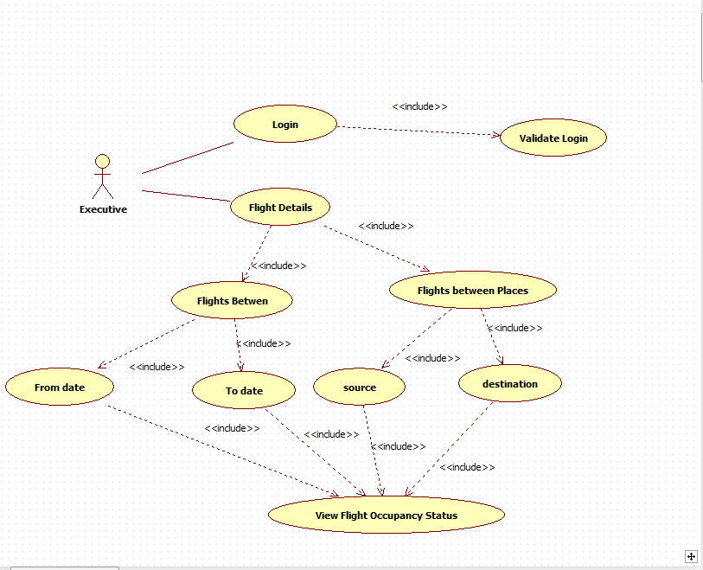

1. Scenarios

Success Scenarios

* Successful executive views flights occupancy details by period in Airline Reservation System
* Wrong Attempts by leaving the From Date field empty
* Wrong Attempts by leaving the To Date field empty
* Wrong Attempts with Invalid From Date and To Date

Failure Scenarios

* Web Server Down
* Database Connectivity Error
* Network Connectivity Error

1. UI Specifications

<< Provide a link to the UI specification document of the Use case. Please don’t embed the document here>>

1. Integration with an already existing System of the <<Customer>>

<< This is especially applicable if the project at hand is an enhancement to an existing system.>>

1. Assumptions

<< List down all the assumptions considered by this use case>>

* The Airline reservation System Portal is up and running

REVISION HISTORY OF THE WORK PRODUCT

<to be maintained by projects>

|  |  |  |  |  |  |
| --- | --- | --- | --- | --- | --- |
| # | Date | Version # | Section Changed | Details of changes made | Approved By |
| 1 |  |  |  |  |  |
| 2 |  |  |  |  |  |